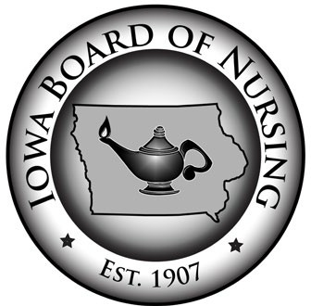**Iowa Board of Nursing**

400 S.W. 8th Street, Suite B, Des Moines, IA 50309-4685

Tel: (515) 281-3255 Fax: (515) 281-4825

Web: nursing.iowa.gov

**MEMORANDUM**

To: Nurse Licensees, Nursing Employers and Nurse Educators

From: Kathy Weinberg, Executive Director

Date: February 7, 2022

Subject: Termination of Proclamation of Disaster Emergency and Licensing Grace Period for Nursing Staff Currently Working on Non-Compact, Out-of-State Licenses

Governor Reynolds recently announced that her Proclamation of Disaster Emergency in response to the COVID-19 pandemic will expire at 11:59 p.m. on February 15, 2022. Accordingly, the State of Iowa will no longer be under a proclaimed state of emergency due to COVID-19 beginning February 16, 2022.

While the Governor’s Proclamations of Disaster Emergency were in effect, the Board of Nursing’s administrative rules authorized nurses who hold active nursing licenses issued by any state, including a non-Compact state, to immediately begin working without first obtaining an Iowa license. *See* Iowa Admin. Code r. 655-3.2(2)(c). But this rule only allows for nursing practice in Iowa without an Iowa license or multi-state license during a proclaimed emergency. Once a state of emergency ends, the Board’s normal licensure requirements apply. Accordingly, beginning February 16, 2022, the rule no longer authorizes nurses to work in Iowa on a non-Compact, out-of-state license.

However, to avoid any disruptions in staffing and patient care, the Board is authorizing a grace period to resume compliance with the Board’s normal licensure requirements. Nurses who are presently working in Iowa based on the emergency-practice rule will have **NINETY (90) DAYS** from February 16, 2022, to obtain an Iowa nursing license or a multi-state license from a Compact state. This means such nurses will have up to and including May 17, 2022, to obtain proper licensure.

Nurses who hold licenses issued by non-Compact states may apply for licensure by endorsement in accordance with Iowa Administrative Code rule 655-3.5. Applications may be submitted online any time through the [IBON Online Services](https://eservices.iowa.gov/PublicPortal/Iowa/IBON/common/index.jsp). Any nurses who have questions or need assistance with applying for an Iowa license are encouraged to contact the Board office.