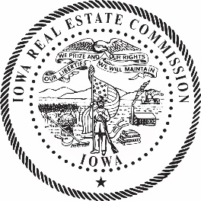

**IOWA REAL ESTATE COMMISSION**

200 East Grand, Suite 350, Des Moines, IA

Bureau Conference Room via Zoom

**Monday, April 24, 2023**

**11:00 a.m.**

**Meeting Agenda**

1. Call to Order
2. Commissioner Reports
3. Staff Reports
   1. John Lundquist, Assistant Attorney General
   2. Lori SchraderBachar, PLB Bureau Chief
   3. Renee Paulsen, Executive Officer

4. Vote to amend Iowa Administrative Code 193 per NOIA ARC 6946C

1. Public Comment
2. Adjourn

Board meetings are open to the public. Members of the public may attend the Commission meeting in-person at the Commission’s office or online by using the [Zoom link](https://us02web.zoom.us/j/81291877744?pwd=ZGtyTTBvMmRIM3gxMG5hN0pTWnprQT09) (Meeting ID: 849 4944 8065; Passcode: 550763). The site is accessible for people with mobility limitations. If you are a person with a disability and need a reasonable accommodation to participate, please contact Renee Paulsen, (515) 725-9028 or renee.paulsen@iowa.gov, at least 48 hours in advance of the meeting.