Frequently Asked Questions about Nursing Practice during the

COVID-19 Pandemic and Emergency Proclamations in Iowa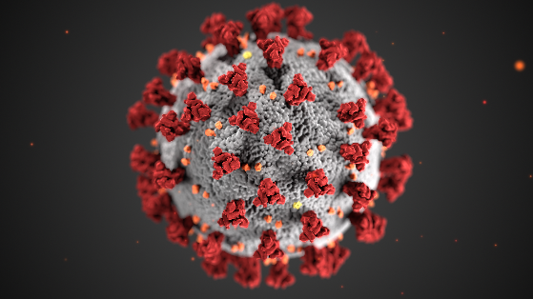

- If I live and work in non-compact state and would like to work in Iowa during the public health disaster emergency, do I need an Iowa license?
- No, you may work on a non-compact state license until the termination of the public health disaster emergency.

- Can I work on my inactive Iowa nursing license during the public health disaster emergency?
- Yes, as long as the license has not been inactive greater than five years, per the Governor’s Proclamation dated March 17, 2020, and extended on April 3, 2020

- Can I get an emergency nursing license?
- Though the Governor has authorized the Iowa Board of Nursing to issue emergency licenses, the Board is in the process of drafting emergency rules defining the requirements. Staff is working on the operational procedures to issue an emergency license.

- Do I need to complete continuing education (CE) to renew my license during the public health disaster emergency?
- You may renew your nursing license without the required CE documentation.
- A check box has been added to the renewal application to allow for this exemption during the public health disaster emergency.

- Should I renew my nursing license before it expires during the public health disaster emergency?
- Yes, we encourage timely nursing licensure renewal as usual. If you are unable to renew your license on time during the public health disaster emergency your license will remain active with the expiration date noted and you will not be charged a late fee.
- Once the emergency is lifted you must renew within 60 days.

- I am applying for an Iowa nursing license by endorsement and I cannot get my fingerprints taken for the required background check?
- Your application will be processed without the fingerprint cards.
- All fees will apply.
- Applicants must still answer all questions on the application and provide any required information relating to their criminal histories.
- Licenses processed without a fingerprint card will be designated as single-state licenses per the Nurse Licensure Compact.

- How long do I have to get my fingerprint cards once the emergency has been lifted?
- Within 60 days of the expiration or termination of the public health disaster emergency the background check packet (completed waiver form and completed fingerprint cards) must be returned.

- My license has been inactive for more than 5 years, can I still help during the emergency?
- You may not practice nursing with an inactive license more than 5 years old. You may consider volunteering by registering at the Iowa Statewide Emergency Registry of Volunteers (i-SERV). Follow the directions on that site for consideration.

- My license is revoked/suspended/surrendered. Can I return to work under Governor Reynolds’s March 17, 2020, Proclamation which addresses working on inactive licenses?
- No, you must first satisfy the stipulations of your order and/or possibly go through the formal reinstatement process. Please call the main phone number of 515.281.3255. Ask to talk to the investigator of the day.

- I am licensed as an ARNP in another state. May I work in Iowa on my out of state ARNP license during the public health emergency disaster?
- An ARNP is required to hold an active RN license. In accordance with Iowa Administrative Code 655, 3.2(2)c. ARNPs are eligible to work on their out of state RN license during the public health emergency disaster. The ARNP may also care for patients in Iowa on their out of state ARNP license pursuant to Iowa Administrative Code 655, 3.2(2)c. during the public health emergency disaster.

- I am renewing my ARNP license, am I still required to take the Opioid Prescribing continuing education?
- Yes, by law you are required to take this education, according to 655 IAC, 7.6(8). An ARNP who has prescribed opioids to a patient during the renewal cycle is required to complete a minimum of two contact hours of continuing education (CE) regarding the U.S. Centers for Disease Control and Prevention guideline for prescribing opioids for chronic pain, including recommendations on limitations on dosages and the length of prescriptions, risk factors for abuse, and nonopioid and nonpharmacologic therapy options, as a condition of license renewal every three years.
- Prescribing is defined as follows: To issue a prescription to a patient, which is then dispensed at a pharmacy.

