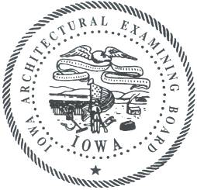
IOWA ARCHITECTURAL EXAMINING BOARD
A G E N D A
200 E. Grand Avenue, Suite 350, Des Moines | Bureau Conference Room
Wednesday, November 12, 2014 | 10 A.M.

10 a.m. Call to Order Forquer
Introductions/Announcements
Approval of Agenda
Approval of Minutes from September 9, 2014 open session
Approval of Minutes from September 9, 2014 closed session
Approval of Minutes from October 23, 2014 open session

10:10 Board Member Reports
Governor’s New Board Member Orientation Dausener, Kamerman, and Purdy
ARRC Meeting Forquer

10:20 Administrative Reports
Pam Griebel, Assistant Attorney General
Lori SchraderBachar, Board Administrator and Site Manager
Renee Paulsen, Licensing Specialist

10:25 Rules Committee Forquer
193 IAC 14 Implications
5-year Rolling Review

11:00 PLB Strategic Plan Bassler and SchraderBachar

11:15 NCARB
MBM Chair/MBE Conference Report Bassler

11:25 Public Comment

11:30 Complaints— Closed Session All
In accordance with Iowa Code §§ 21.5(1)(a) & (d) and 272C.6(4), the Board will go into closed session to review pending licensee discipline cases and investigations, including any cases ready for final resolution through closure or consent order.
- 14-03
- 14-04
- 14-10

11:45 Complaints—Open Session All
The Board will return to open session to take action on items discussed in closed session.
The Board will discuss unlicensed practice discipline cases and investigations.
- 08-12

12 p.m. Adjourn Forquer

If you are a person with a disability and need a reasonable accommodation to participate, please contact Lori SchraderBachar, (515) 725-9030 or lori.schraderbachar@iowa.gov, at least 48 hours in advance of the meeting.

Tentative 2015 Meeting Dates:
January 13
March 10
May 12
July 14
September 8
November 10

