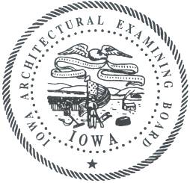
IOWA ARCHITECTURAL EXAMINING BOARD
A G E N D A
200 E. Grand Avenue, Suite 350, Des Moines | Bureau Conference Room
Wednesday, March 26, 2014 | 9:30 A.M.

- Call to Order
Introductions/Announcements
Approval of Agenda
Approval of Minutes from January 14, 2014 (open and closed)

- Registration issues facing border communities
City of Council Bluffs Building Division, Steve Carmichael, CBO & Scott Charleson, certified building inspector

- Board Member Reports
- Administrative Reports
Pam Griebel, Assistant Attorney General
Lori SchraderBachar, Board Administrator and Site Manager
Jennifer Morrison, Licensing Specialist

- 2014 Legislation

- Rule Changes
Chapter 1 – Adopt
Chapter 2 –Adopt

- Board policy on complaints

- NCARB
Report from Regional Meeting
IDP Feedback

- Recognition of outgoing Board Members Allers, Tom Clause, and Dr. Sue Jarboe

- Public Comment

- Complaints— Closed Session
In accordance with Iowa Code §§ 21.5(1)(a) & (d) and 272C.6(4), the Board will go into closed session to review pending licensee discipline cases and investigations, including any cases ready for final resolution through closure or consent order.
  - 13-04
  - 13-15
  - 14-02
  - 14-03
  - 14-04
  - 14-05

- Complaints—Open Session
The Board will return to open session to take action on items discussed in closed session.
The Board will discuss unlicensed practice discipline cases and investigations.
  - 08-12
  - 14-01

- Future Meeting dates
May 13, 2014
July 8, 2014
September 9, 2014
November 11, 2014 (State Holiday)

- Adjourn

If you are a person with a disability and need a reasonable accommodation to participate, please contact Lori SchraderBachar, (515) 725-9030 or lori.schraderbachar@iowa.gov, at least 48 hours in advance.

